
MXBON Wire Tacking System for PCB Assembly
- Fast Wire Tacking and Connector Reinforcement for Reliable Electronics Assembly
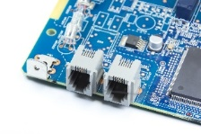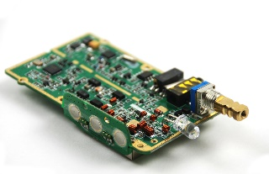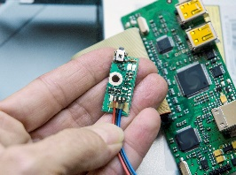
Assembly Risks Without Proper Wire Fixing:
- Unsecured wires and connectors can shift during handling, use, or transportation
- Repeated connector plug/unplug cycles introduce mechanical stress
- Cable movement and vibration may loosen connectors or alter wire positions
- Added strain on solder joints can cause intermittent contact or signal instability
- Risk of premature product failure increases over time without proper stabilization
- Reliable wire tacking is essential to ensure long-term device Performance MXBON
Mxbon Wire Tacking System
- Provides fast, efficient wire securing and connector reinforcement during PCB assembly
- Includes MXBON 21382 wire-tacking cyanoacrylate adhesive and MXBON 027455 rapid-curing accelerator
- Delivers quick, controlled bonding for a cleaner, more stable assembly process
- Improves long-term reliability by preventing wire movement and connector loosening
Simple Application Process
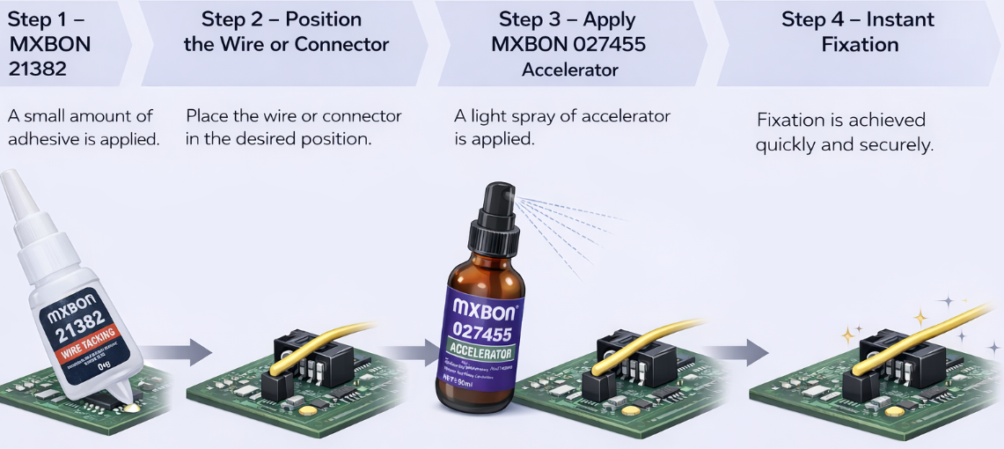
MXBON Adhesives
MXBON Adhesives is a global manufacturer specializing in high-performance cyanoacrylate and industrial adhesive technologies, providing reliable bonding solutions for electronics and industrial assembly. For more information or to request a sample, contact us today! Chris.sorenson@surehold.com

